Trapezoidal-Base Prism
# Source: AI Source: Provided by: [Data Path: Persons Table -> ID Column: 1, Name_En Column: Motasem Essam] -> From: [ChatGPT] on [7/25/2026]
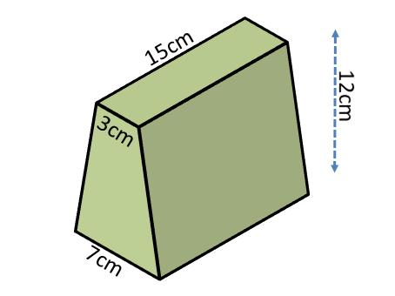
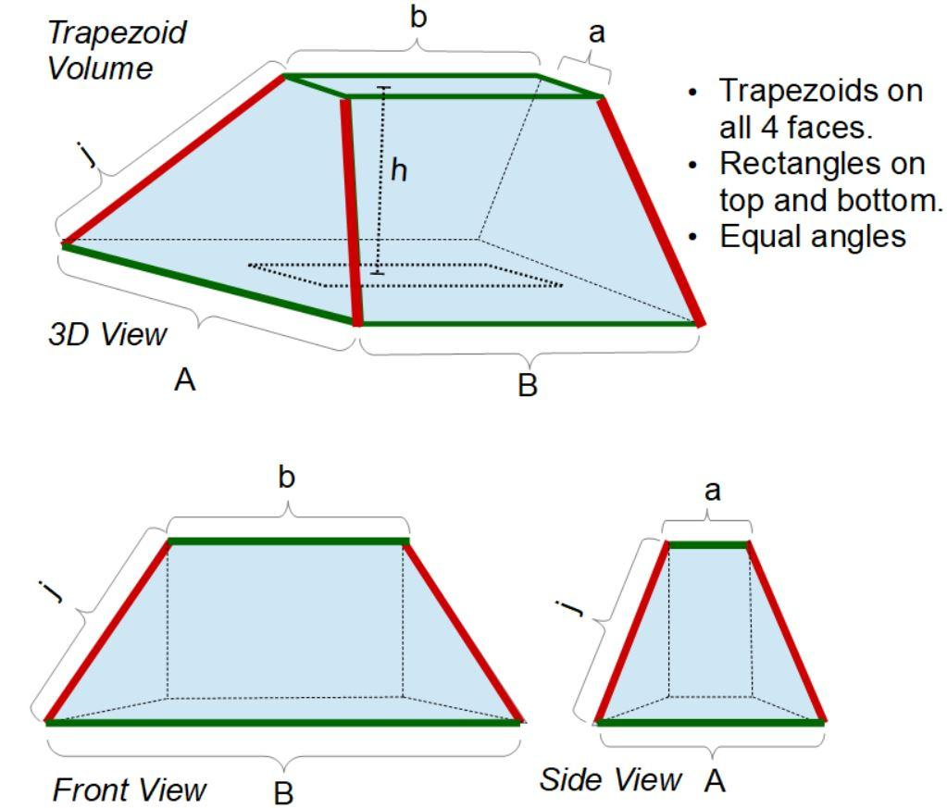
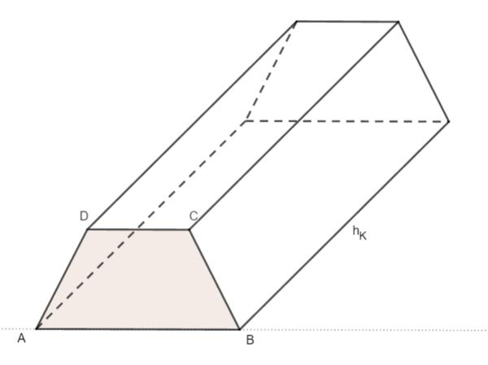

Definition
# Source: AI Source: Provided by: [Data Path: Persons Table -> ID Column: 1, Name_En Column: Motasem Essam] -> From: [ChatGPT] on [7/25/2026]
A trapezoidal-base prism is a three-dimensional polyhedron with two congruent, parallel trapezoidal bases connected by four lateral faces.
A trapezoid is a quadrilateral with at least one pair of parallel opposite sides under the inclusive definition commonly used in mathematics. Some curricula use an exclusive definition requiring exactly one pair of parallel sides.
A trapezoidal-base prism has:
- 2 trapezoidal bases.
- 4 lateral faces.
- 6 faces in total.
- 12 edges.
- 8 vertices.
In a right trapezoidal-base prism, the lateral edges are perpendicular to the bases, so the lateral faces are rectangles. In an oblique trapezoidal-base prism, the lateral edges are inclined, and the lateral faces are parallelograms.

Simple Definition
# Source: AI Source: Provided by: [Data Path: Persons Table -> ID Column: 1, Name_En Column: Motasem Essam] -> From: [ChatGPT] on [7/25/2026]
A trapezoidal-base prism is a 3D solid with two matching trapezoid-shaped ends joined by four side faces.
Imagine extending a flat trapezoid straight through space to create a solid with depth.

Classification Tree
# Source: AI Source: Provided by: [Data Path: Persons Table -> ID Column: 1, Name_En Column: Motasem Essam] -> From: [ChatGPT] on [7/25/2026]
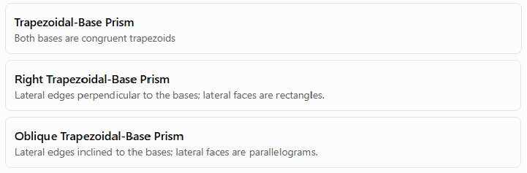
Trapezoidal-Base Prism
Both bases are congruent trapezoids
Right Trapezoidal-Base Prism
Lateral edges perpendicular to the bases; lateral faces are rectangles.
Oblique Trapezoidal-Base Prism
Lateral edges inclined to the bases; lateral faces are parallelograms.
The prism can also be described by the specific type of trapezoid used for its bases, such as an isosceles trapezoid or a right trapezoid.

Key Characteristics
# Source: AI Source: Provided by: [Data Path: Persons Table -> ID Column: 1, Name_En Column: Motasem Essam] -> From: [ChatGPT] on [7/25/2026]
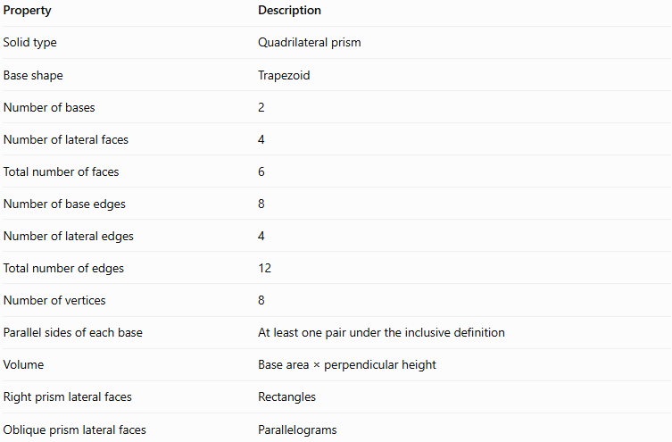
Property | Description
Solid type | Quadrilateral prism
Base shape | Trapezoid
Number of bases | 2
Number of lateral faces | 4
Total number of faces | 6
Number of base edges | 8
Number of lateral edges | 4
Total number of edges | 12
Number of vertices | 8
Parallel sides of each base | At least one pair under the inclusive definition
Volume | Base area × perpendicular height
Right prism lateral faces | Rectangles
Oblique prism lateral faces | Parallelograms

Geometric Representation
# Source: AI Source: Provided by: [Data Path: Persons Table -> ID Column: 1, Name_En Column: Motasem Essam] -> From: [ChatGPT] on [7/25/2026]
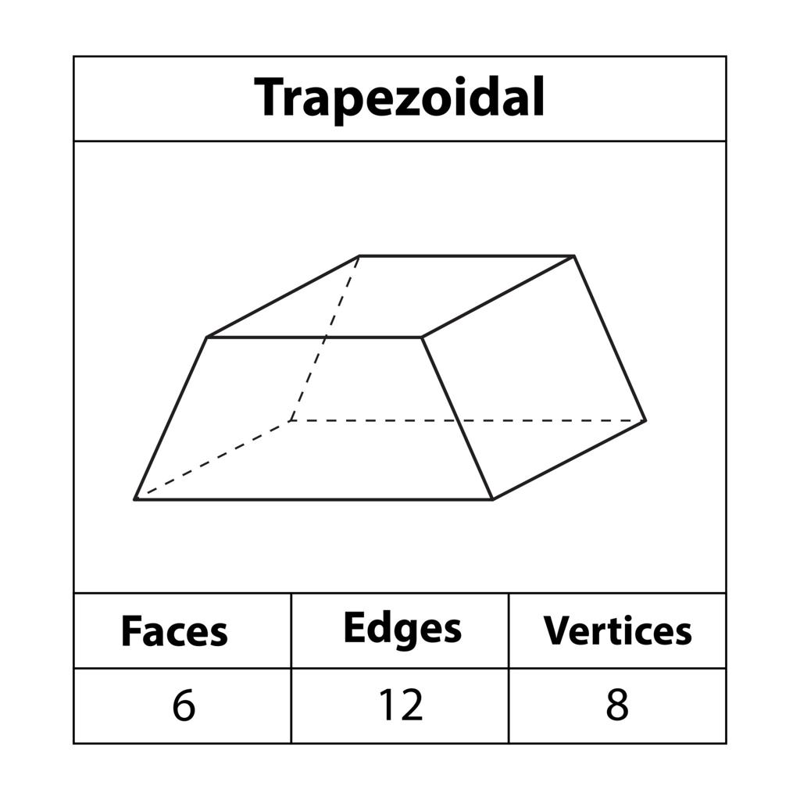
The main components are:
- Base faces: The two congruent, parallel trapezoids.
- Lateral faces: Four faces connecting corresponding sides of the bases.
- Base edges: Eight edges in total, four on each trapezoidal base.
- Lateral edges: Four edges connecting corresponding vertices.
- Vertices: Eight corner points.
- Base altitude: The perpendicular distance between the parallel sides of a trapezoidal base.
- Prism height: The perpendicular distance between the two base planes.
Important distinction: The base altitude measures the height of the trapezoid itself. The prism height measures the distance between its two bases. These are different measurements.

Mathematical Representations and Formulas
# Source: AI Source: Provided by: [Data Path: Persons Table -> ID Column: 1, Name_En Column: Motasem Essam] -> From: [ChatGPT] on [7/25/2026]
Let:
- $a$ and $b$ = lengths of the parallel sides of the trapezoid.
- $c$ and $d$ = lengths of its nonparallel sides.
- $t$ = perpendicular altitude of the trapezoidal base.
- $B$ = area of one base.
- $p$ = perimeter of the base.
- $h$ = perpendicular height of the prism.
- $A_{L}$ = lateral surface area.
- $A_{T}$ = total surface area.
- $V$ = volume.

A. Base area
# Source: AI Source: Provided by: [Data Path: Persons Table -> ID Column: 1, Name_En Column: Motasem Essam] -> From: [ChatGPT] on [7/25/2026]
The area of a trapezoid is half the sum of its parallel sides multiplied by its altitude:
$$\boxed{B=\frac{12}{\left(a+b\right)}t}$$

B. Base perimeter
# Source: AI Source: Provided by: [Data Path: Persons Table -> ID Column: 1, Name_En Column: Motasem Essam] -> From: [ChatGPT] on [7/25/2026]
The perimeter is the sum of all four sides:
$$\boxed{p=a+b+c+d}$$

C. Volume
# Source: AI Source: Provided by: [Data Path: Persons Table -> ID Column: 1, Name_En Column: Motasem Essam] -> From: [ChatGPT] on [7/25/2026]
The volume of a prism is its base area multiplied by its perpendicular height:
$$V=Bh$$
For a trapezoidal-base prism:
$$\boxed{V=\frac{12}{\left(a+b\right)}th}$$
This formula works for both right and oblique prisms, using the perpendicular distance between the bases for $h$.

D. Lateral surface area
# Source: AI Source: Provided by: [Data Path: Persons Table -> ID Column: 1, Name_En Column: Motasem Essam] -> From: [ChatGPT] on [7/25/2026]
For a right trapezoidal-base prism, the lateral faces are rectangles, so:
$$A_{L}=ph$$
Substituting the base perimeter:
$$\boxed{A_{L}=\left(a+b+c+d\right)h}$$
For an oblique trapezoidal-base prism, calculate the areas of its four lateral parallelograms and add them together. The formula $A_{L}=ph$ does not generally apply when $h$ is the perpendicular distance between the bases.

E. Total surface area
# Source: AI Source: Provided by: [Data Path: Persons Table -> ID Column: 1, Name_En Column: Motasem Essam] -> From: [ChatGPT] on [7/25/2026]
The total surface area is the sum of the lateral surface area and the two base areas:
$$A_{T}=A_{L}+2B$$
For a right trapezoidal-base prism:
$$\boxed{A_{T}=\left(a+b+c+d\right)h+\left(a+b\right)t}$$

Worked Examples
# Source: AI Source: Provided by: [Data Path: Persons Table -> ID Column: 1, Name_En Column: Motasem Essam] -> From: [ChatGPT] on [7/25/2026]
Example 1: Counting faces, edges, and vertices
Problem: How many faces, edges, and vertices does a trapezoidal-base prism have?
A trapezoid has four sides, so $n=4$.
For an $n$-gonal prism:
$$F=n+2, E=3n, V=2n$$
Therefore:
- Faces: $F=4+2=6$
- Edges: $E=3\left(4\right)=12$
- Vertices: $V=2\left(4\right)=8$
Answer: 6 faces, 12 edges, and 8 vertices.
Example 2: Calculating the base area
Problem: A trapezoidal base has parallel sides of $10\text{ cm}$ and $6\text{ cm}$, with an altitude of $4\text{ cm}$. Find its area.
Using the formula:
$$B=\frac{12}{\left(a+b\right)}t$$
Substitute the values:
$$B=\frac{12}{\left(10+6\right)}\left(4\right)$$
$$B=\frac{12}{\left(16\right)}\left(4\right)$$
$$\boxed{B=32{\text{ cm}}^{2}}$$
Example 3: Calculating the volume
Problem: A trapezoidal-base prism has a base area of $32{\text{ cm}}^{2}$ and a perpendicular prism height of $9\text{ cm}$. Find its volume.
Using:
$$V=Bh$$
$$V=32\left(9\right)$$
$$\boxed{V=288{\text{ cm}}^{3}}$$
Example 4: Calculating lateral and total surface areas
Problem: A right trapezoidal-base prism has a trapezoidal base with parallel sides of $10\text{ cm}$ and $6\text{ cm}$, two nonparallel sides of $5\text{ cm}$ each, a base altitude of $4\text{ cm}$, and a prism height of $8\text{ cm}$. Find its lateral and total surface areas.
Step 1: Calculate the base perimeter.
$$p=10+6+5+5=26\text{ cm}$$
Step 2: Calculate the lateral surface area.
$$A_{L}=ph$$
$$A_{L}=26\left(8\right)$$
$$\boxed{A_{L}=208{\text{ cm}}^{2}}$$
Step 3: Calculate the base area.
$$B=\frac{12}{\left(10+6\right)}\left(4\right)=32{\text{ cm}}^{2}$$
Step 4: Calculate the total surface area.
$$A_{T}=A_{L}+2B$$
$$A_{T}=208+2\left(32\right)$$
$$\boxed{A_{T}=272{\text{ cm}}^{2}}$$
Example 5: Verifying Euler’s formula
Euler’s formula for a convex polyhedron is:
$$V-E+F=2$$
For this prism, $V=8$, $E=12$, and $F=6$.
$$8-12+6=2$$
Therefore, Euler’s formula is satisfied.

Types of Trapezoidal Bases
# Source: AI Source: Provided by: [Data Path: Persons Table -> ID Column: 1, Name_En Column: Motasem Essam] -> From: [ChatGPT] on [7/25/2026]
A trapezoidal-base prism can be further classified by the shape of its trapezoidal bases.

Isosceles trapezoid base
# Source: AI Source: Provided by: [Data Path: Persons Table -> ID Column: 1, Name_En Column: Motasem Essam] -> From: [ChatGPT] on [7/25/2026]
The nonparallel sides are equal in length. The base angles along each parallel side are equal, and the diagonals are equal.
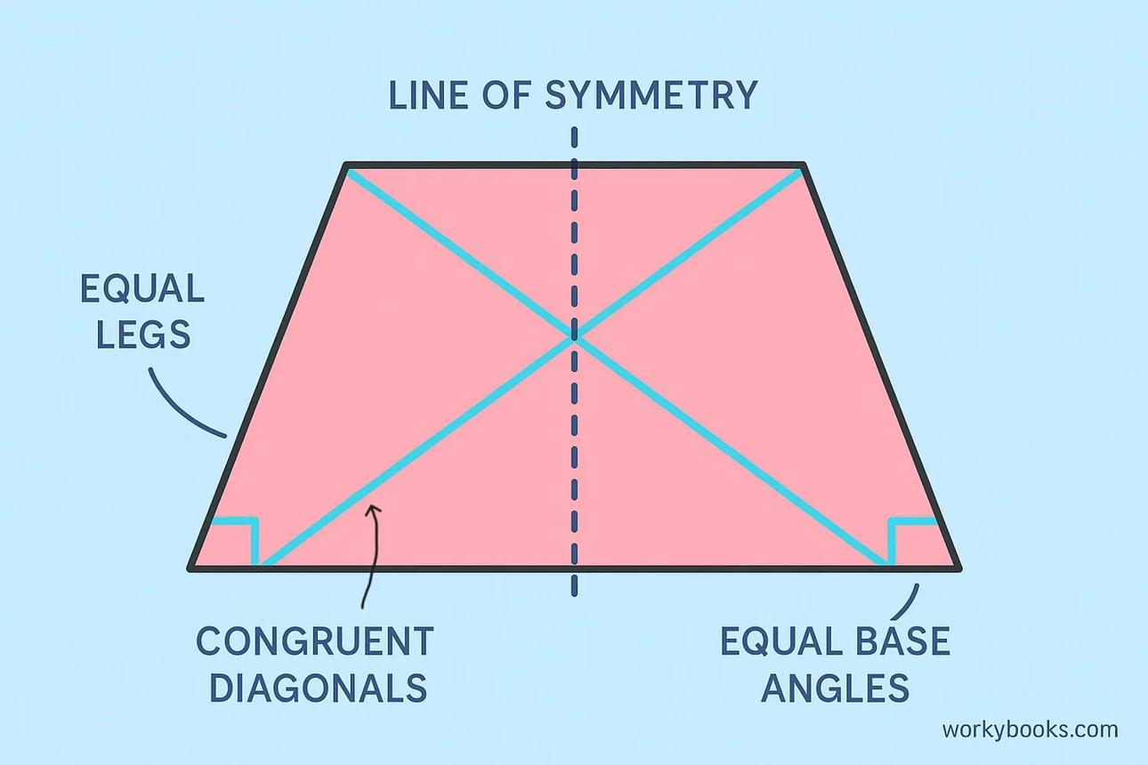

Right trapezoid base
# Source: AI Source: Provided by: [Data Path: Persons Table -> ID Column: 1, Name_En Column: Motasem Essam] -> From: [ChatGPT] on [7/25/2026]
One leg is perpendicular to the parallel sides, creating two right angles.
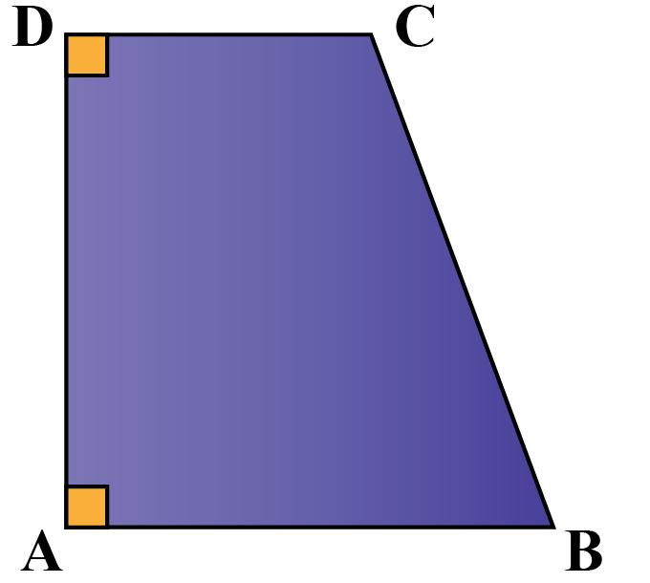

General or scalene trapezoid base
# Source: AI Source: Provided by: [Data Path: Persons Table -> ID Column: 1, Name_En Column: Motasem Essam] -> From: [ChatGPT] on [7/25/2026]
The nonparallel sides are typically unequal, and the trapezoid has no additional symmetry in the general case.
These describe the base shape, not whether the prism itself is right or oblique. For example, an oblique prism can have isosceles trapezoids as its bases.
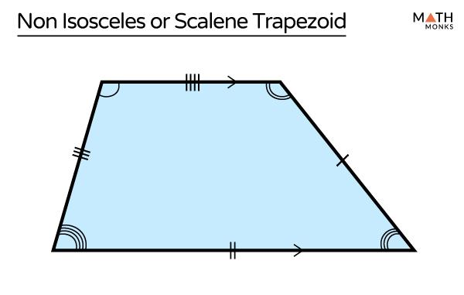

Comparison with Other Quadrilateral Prisms
# Source: AI Source: Provided by: [Data Path: Persons Table -> ID Column: 1, Name_En Column: Motasem Essam] -> From: [ChatGPT] on [7/25/2026]
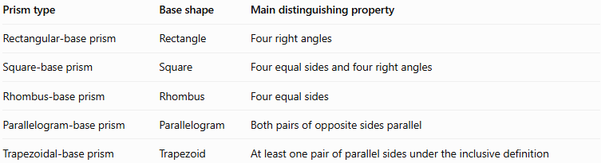
Prism type | Base shape | Main distinguishing property
Rectangular-base prism | Rectangle | Four right angles
Square-base prism | Square | Four equal sides and four right angles
Rhombus-base prism | Rhombus | Four equal sides
Parallelogram-base prism | Parallelogram | Both pairs of opposite sides parallel
Trapezoidal-base prism | Trapezoid | At least one pair of parallel sides under the inclusive definition
The classification depends on the base polygon. All five types have the same basic prism counts: 6 faces, 12 edges, and 8 vertices.
Note that definitions of trapezoid vary between curricula. Under the exclusive definition, a parallelogram is not a trapezoid; under the inclusive definition, it is.

Constructing Trapezoidal-Base Prism in Solid Geometry

Instruments Used
# Source: AI Source: Provided by: [Data Path: Persons Table -> ID Column: 1, Name_En Column: Motasem Essam] -> From: [ChatGPT] on [7/25/2026]
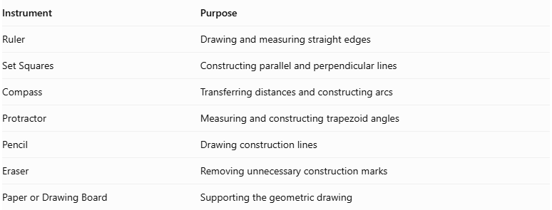
Instrument | Purpose
Ruler | Drawing and measuring straight edges
Set Squares | Constructing parallel and perpendicular lines
Compass | Transferring distances and constructing arcs
Protractor | Measuring and constructing trapezoid angles
Pencil | Drawing construction lines
Eraser | Removing unnecessary construction marks
Paper or Drawing Board | Supporting the geometric drawing

Construction Procedures

Isometric Construction
# Source: AI Source: Provided by: [Data Path: Persons Table -> ID Column: 1, Name_En Column: Motasem Essam] -> From: [ChatGPT] on [7/25/2026]
- Determine the lengths of the two parallel sides and the two legs of the trapezoidal base.
- Determine the trapezoid's interior angles and perpendicular height.
- Determine the required prism height.
- Draw the first trapezoidal base using a ruler and protractor.
- Represent the trapezoid in the selected isometric drawing orientation.
- From each base vertex, draw a lateral edge representing the prism height.
- Ensure that all lateral edges are equal and parallel.
- Draw the second congruent trapezoid at the opposite ends of the lateral edges.
- Connect the corresponding vertices to complete the four lateral faces.
- Distinguish visible and hidden edges and label the dimensions.
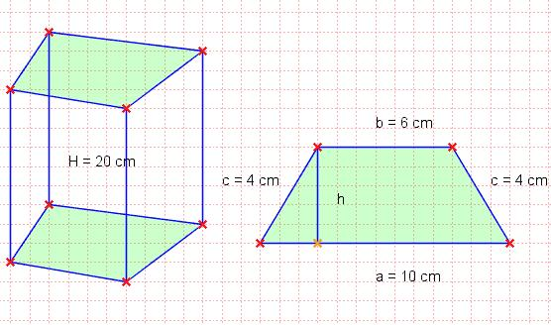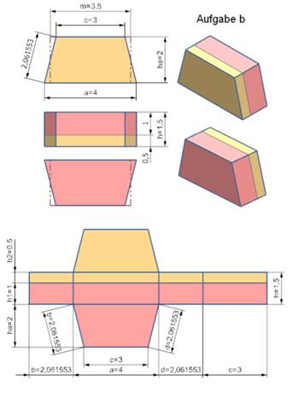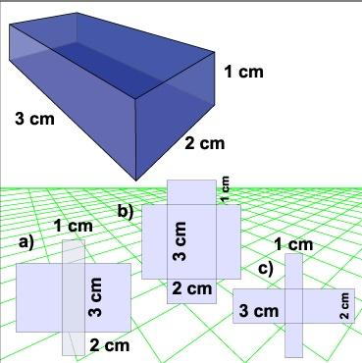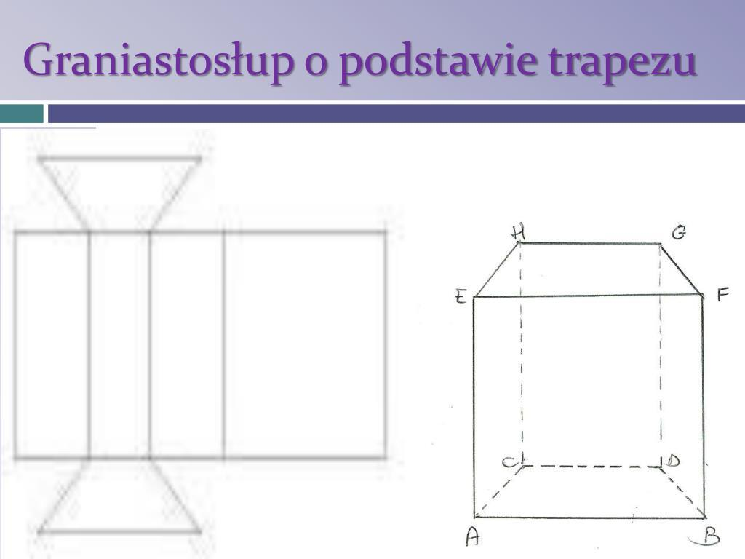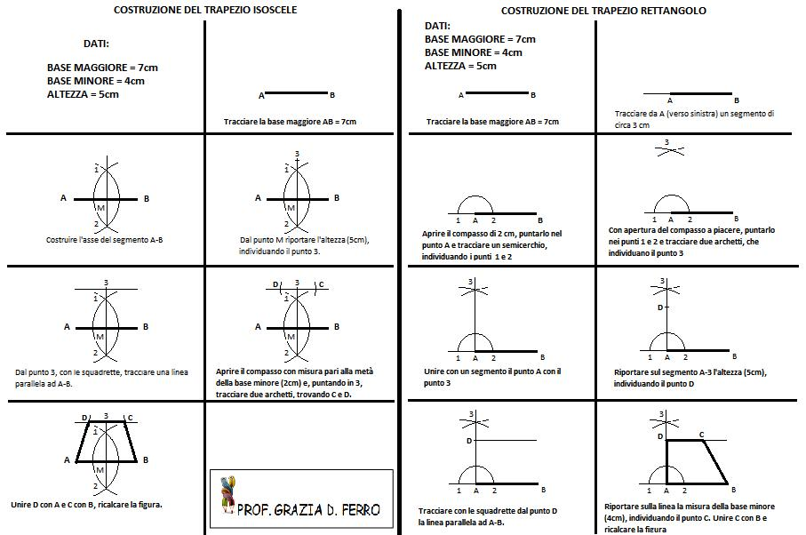

Orthographic Construction
# Source: AI Source: Provided by: [Data Path: Persons Table -> ID Column: 1, Name_En Column: Motasem Essam] -> From: [ChatGPT] on [7/25/2026]
- Determine the trapezoid's parallel-side lengths, leg lengths, angles, and prism height.
- Draw the top view according to the selected viewing orientation.
- Draw the front view showing the trapezoidal base or its corresponding projected shape.
- Draw the side view showing the relevant base dimension and prism height.
- Align the three views according to the selected orthographic projection convention.
- Ensure that corresponding dimensions are consistent.
- Add visible and hidden lines where necessary.
- Label the base dimensions and prism height.

Face-Based Construction
# Source: AI Source: Provided by: [Data Path: Persons Table -> ID Column: 1, Name_En Column: Motasem Essam] -> From: [ChatGPT] on [7/25/2026]
- Draw the first trapezoidal base.
- Determine the required prism height.
- Draw a second congruent trapezoid at the required distance.
- Keep both bases parallel.
- Connect the corresponding vertices of the two trapezoids.
- Complete the four lateral faces.
- For a right prism, ensure that the connecting edges are perpendicular to the base planes.
- Refine the edges and visible surfaces.

Edge-Based Construction
# Source: AI Source: Provided by: [Data Path: Persons Table -> ID Column: 1, Name_En Column: Motasem Essam] -> From: [ChatGPT] on [7/25/2026]
- Select a starting vertex.
- Draw the first parallel side of the trapezoidal base.
- Construct the two legs using their required lengths and angles.
- Complete the trapezoid by drawing the second parallel side.
- Draw the four lateral edges from the base vertices.
- Ensure that the lateral edges are equal and parallel.
- For a right prism, construct the lateral edges perpendicular to the base plane.
- Connect the upper endpoints to form the second trapezoid.
- Complete the lateral faces and refine the solid.

Net-Based Construction
# Source: AI Source: Provided by: [Data Path: Persons Table -> ID Column: 1, Name_En Column: Motasem Essam] -> From: [ChatGPT] on [7/25/2026]
- Determine the lengths of the four sides of the trapezoidal base.
- Draw four rectangles representing the lateral faces of a right trapezoidal-base prism.
- Arrange the four rectangles in a connected strip.
- Attach two congruent trapezoids to suitable edges of the strip.
- Ensure that each rectangle has one dimension corresponding to its respective trapezoid side.
- Set the other dimension of each rectangle equal to the prism height.
- Add tabs if needed for physical assembly.
- Cut out the net.
- Fold along the edges and join the matching boundaries to form the prism.
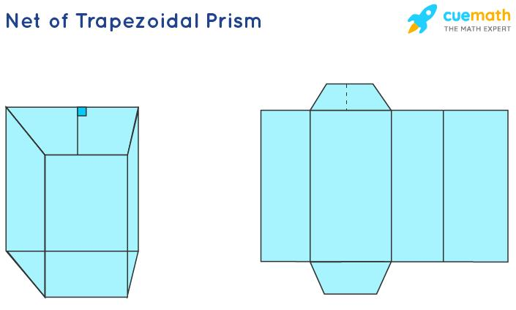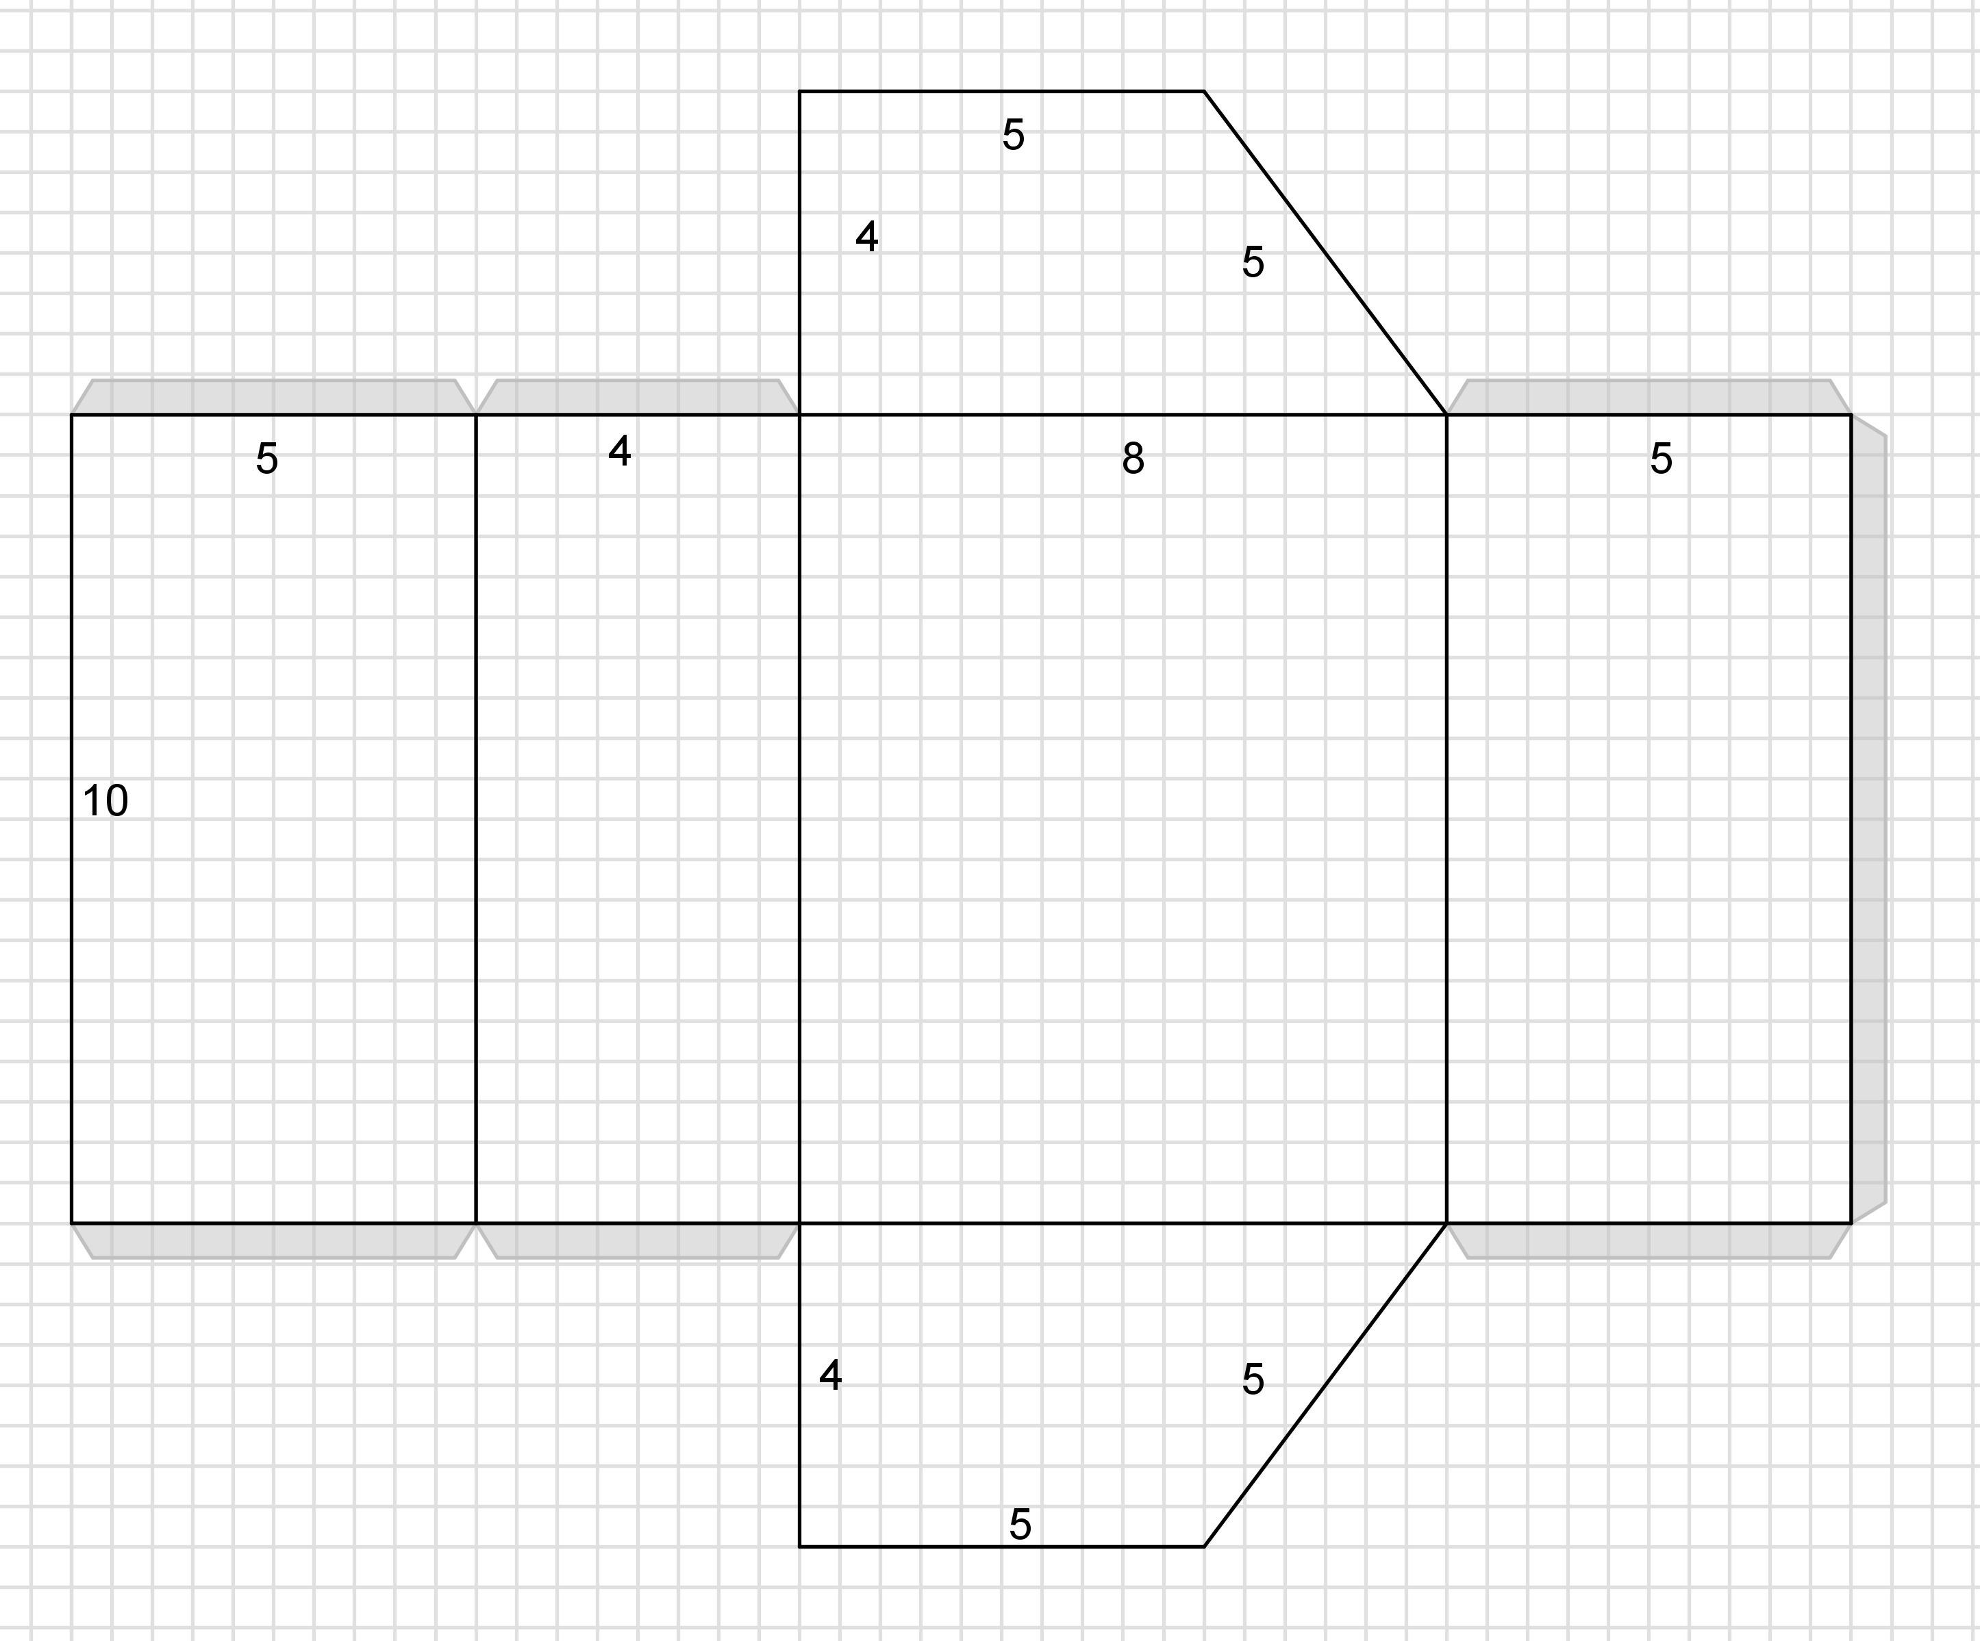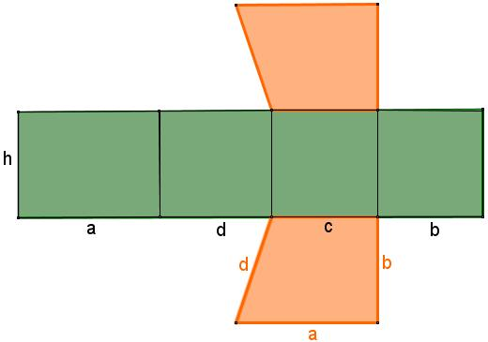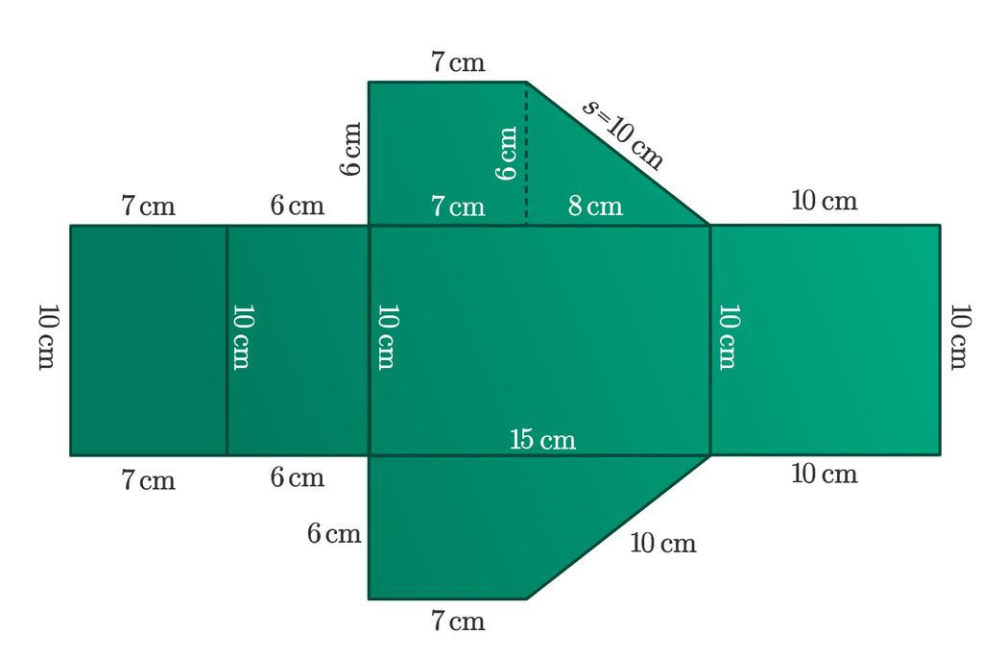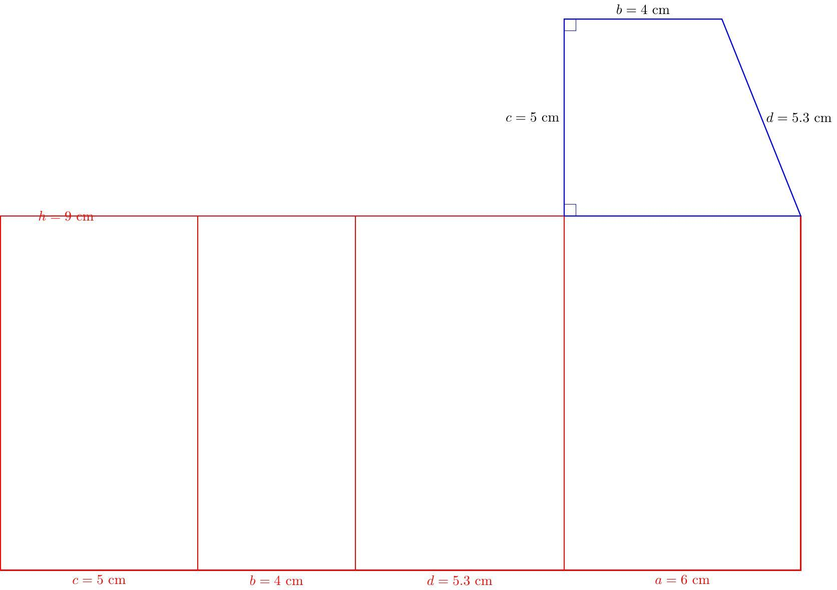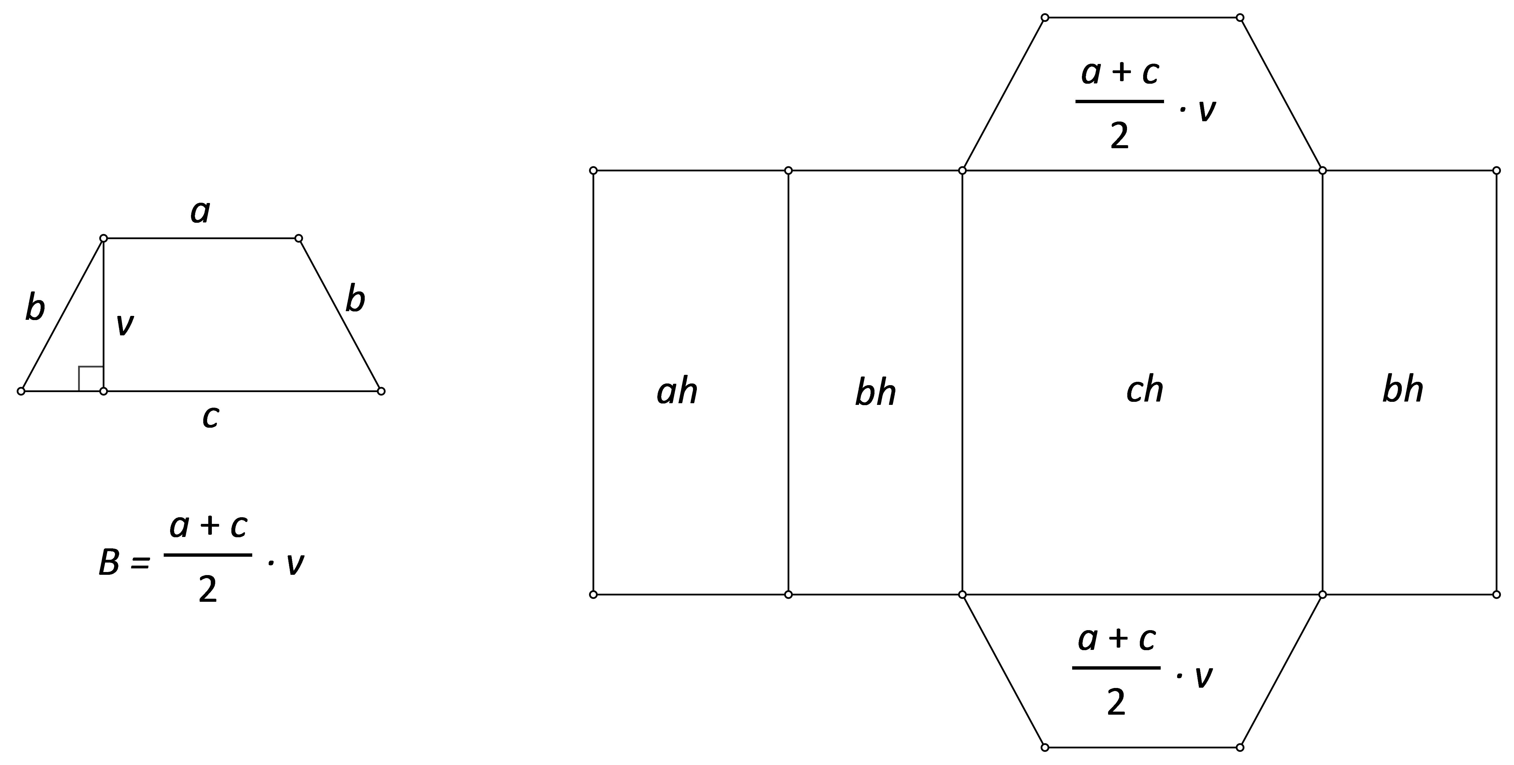

Applications
# Source: AI Source: Provided by: [Data Path: Persons Table -> ID Column: 1, Name_En Column: Motasem Essam] -> From: [ChatGPT] on [7/25/2026]
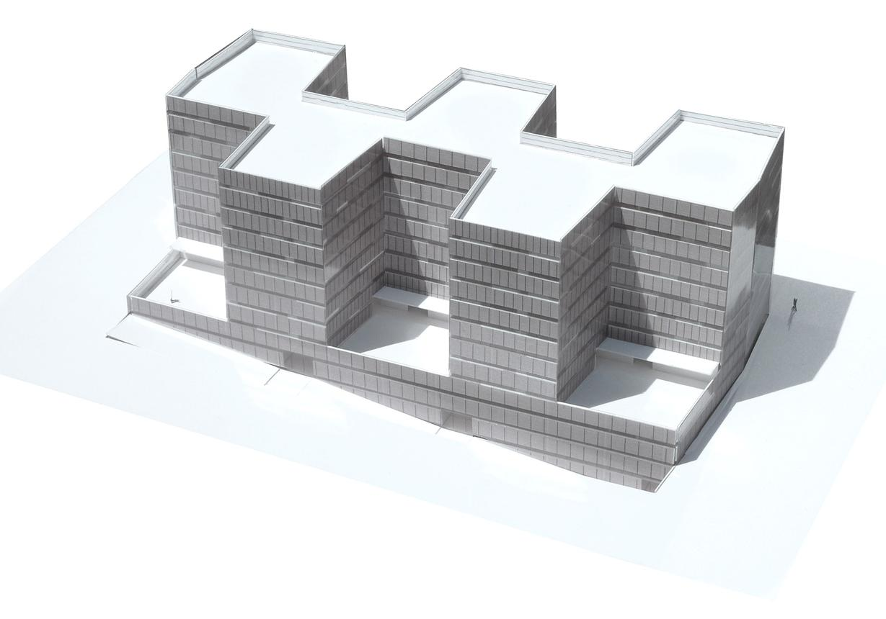
Architecture and construction
Useful for modeling certain sloped structural components, roof forms, and geometric building elements.
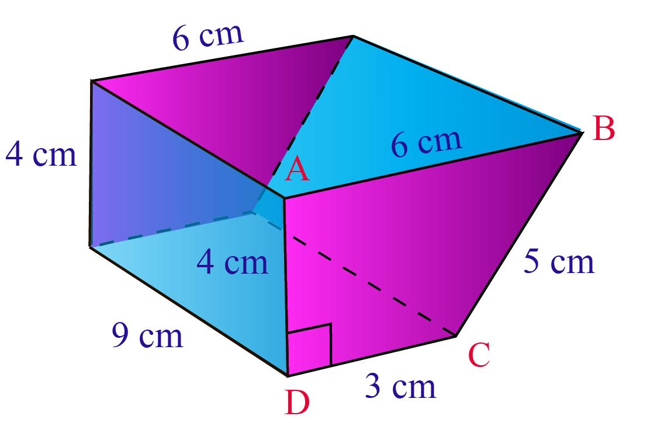
Mathematics education
Helps students understand prisms, trapezoid area, volume, surface area, and the relationships between 2D and 3D shapes.
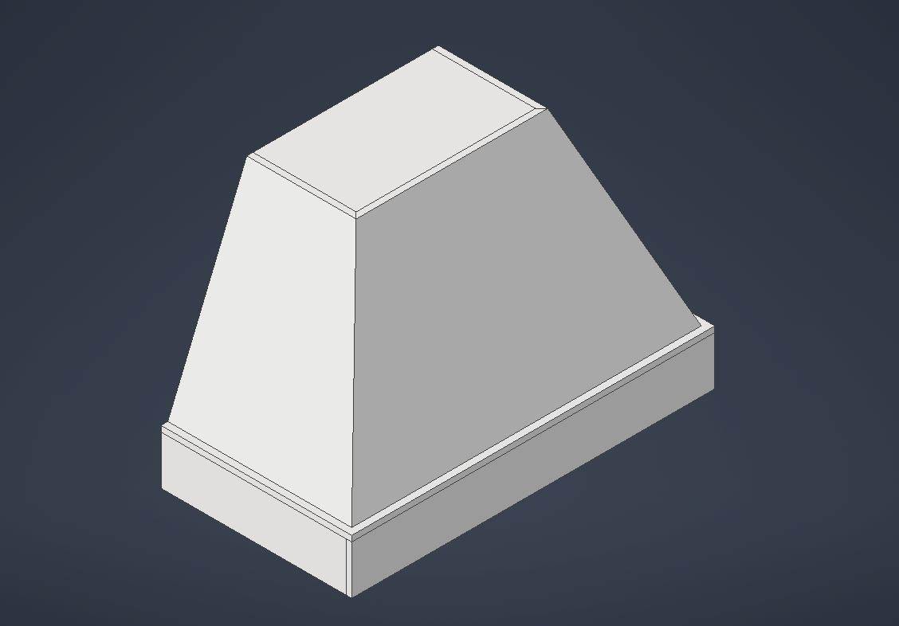
Engineering and 3D modeling
Provides a geometric model for designing and calculating the dimensions of solids with trapezoidal cross-sections.

Key Points
# Source: AI Source: Provided by: [Data Path: Persons Table -> ID Column: 1, Name_En Column: Motasem Essam] -> From: [ChatGPT] on [7/25/2026]
- A trapezoidal-base prism has two congruent, parallel trapezoidal bases.
- It has 6 faces, 12 edges, and 8 vertices.
- The area of a trapezoidal base is $B=\frac{1}{2}\left(a+b\right)t$.
- Its volume is $V=Bh$.
- For a right prism, the lateral surface area is $A_{L}=ph$.
- The prism height and the trapezoid's altitude are different measurements.
- Right and oblique prisms are distinguished by the orientation of their lateral edges.
- The exact classification of trapezoids depends on whether the inclusive or exclusive definition is being used.

Conclusion
# Source: AI Source: Provided by: [Data Path: Persons Table -> ID Column: 1, Name_En Column: Motasem Essam] -> From: [ChatGPT] on [7/25/2026]
A trapezoidal-base prism is a quadrilateral prism whose two bases are congruent trapezoids. Its structure follows the general properties of prisms, while its base geometry determines the base area and perimeter. These measurements are used to calculate volume and surface area. Distinguishing the altitude of the trapezoid from the height of the prism is essential for obtaining correct results.

